Abstract title

Author l¹, Author 2² and Author 3³

¹Affiliation 1, City, Country
²Affiliation 2, City, Country
³ Affiliation 3, City, Country

Please write your abstract in Times New Roman 12 pt, one column with bottom, top and side margins of 2,5 cm (as in this form) and do not change the format of the title, authors and affiliation lines. The abstract length should not exceed 2 pages. Abstracts will be produced in black and white only. Therefore, figures in black and white may be included, but bear in mind that the reproduction quality might not be excellent. For figure captions and references [1] we would kindly ask you to use the formats given below. Send the abstract in to wgeppert@fysik.su.se on May 15th 2025 at the latest.

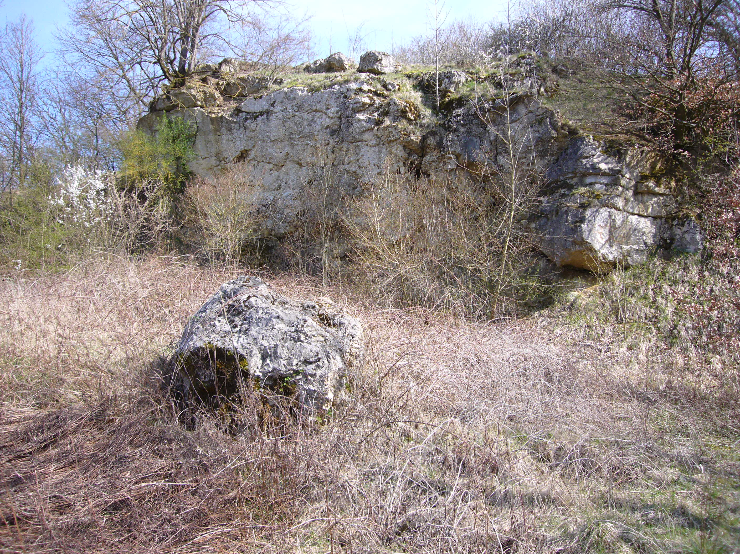

Fig. 1 Outcrop in the Nördlingen Ries Crater

[1] A. B. Author 1 , B. C. Author 2 and C. D. Author 3, Journal, 22, 112 (1999)

